4. Structured practice roadmap (very important)
If you follow this, you can confidently say “I know Entity Framework”.
Phase 1 – LINQ fundamentals
Practice with in-memory lists:
customers.Where(c => c.Age > 18)
.Select(c => new { c.Name, c.Email });
✅ Goal: Write complex LINQ without Googling

Phase 2 – EF Core basics
Practice:
- DbContext
- DbSet
- CRUD operations
Example:
context.Orders.Add(order);
context.SaveChanges();

Phase 3 – Relationships
Practice:
- One-to-many (Customer → Orders)
- Many-to-many (Students ↔ Courses)
- Include and ThenInclude

Phase 4 – Migrations
Practice:
- Add-Migration
- Update-Database
- Changing entity structure safely

Phase 5 – Performance & real-world usage
Practice:
- AsNoTracking
- Projection vs entity loading
- Avoiding N+1 queries

5. Practice questions (use these to test yourself)
If you can confidently answer or implement these, you’re solid:
- What is the difference between IQueryable and IEnumerable?
- When does a LINQ query execute?
- What is lazy loading vs eager loading?
- How does EF translate LINQ to SQL?
- When should you use AsNoTracking()?
- What happens if you forget SaveChanges()?
- How do migrations work internally?

6. Honest benchmark: “Can I say I know EF?”
You can confidently say YES if you can:
✔ Build a small CRUD app
✔ Design entities and relationships
✔ Write non-trivial LINQ queries
✔ Use migrations
✔ Explain performance basics

Let’s do a mock EF Core interview, short and sharp.
I’ll ask → you answer → I’ll correct/refine like a real interviewer.

Question 1 (warm-up – LINQ vs EF)
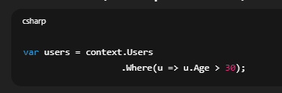
Questions:
- What is the type of users?
- Has the database been hit yet?
- When exactly will SQL be executed?
✅ Question 1: Type of users
Your answer:
depends on data source … IEnumerable or IQueryable
✔ Correct, but say it more confidently and specific to the code:
Best interview answer:
Since context.Users is a DbSet<T>, users is of type IQueryable<User>.
Why this matters:
- Interviewers want you to reason from the actual code, not hypotheticals.

✅ Question 2: Has the database been hit?
Your answer:
No
✔ Correct
Better wording:
No, because IQueryable uses deferred execution and only builds the expression tree.

⚠️ Question 3: When will SQL execute?
Your answer:
When we put .ToList()
✔ Mostly correct, but slightly incomplete.
Corrected, complete answer:
SQL is executed when the query is materialized, for example by:
- ToList()
- First() / FirstOrDefault()
- Single()
- Any()
- Count()
- foreach

Question 2 (recap)
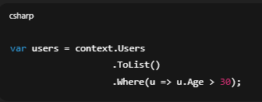
✅ 1. Where does filtering happen?
Your answer:
In memory as after applying ToList it becomes List<T>
✔ Correct
Interview-polished version:
Filtering happens in memory, because ToList() materializes the data before Where() is applied.

✅ 2. What is the type of users?
Your answer:
List<T>
⚠️ Almost — small correction.
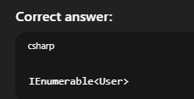
Why?
- ToList() → returns List<User>
- Where() → returns IEnumerable<User>
So the final variable type is IEnumerable<User>.
This is a very common interview trap.

⚠️ 3. What is the performance issue?
Your answer:
we are applying where after tolist , so again to execute the code we have to materialise it
This part needs correction.
❌ What is NOT the issue
- There is no second materialization
- Where() does not hit DB again
✅ Actual performance issue (important)
ToList() loads ALL rows from the database, and filtering happens in memory instead of SQL.
So:
- More data transferred
- More memory usage
- Slower execution
Correct interview answer:
The performance issue is that ToList() materializes all records from the database, and filtering happens in memory instead of being translated to SQL.

Ready for Question 3? (N+1 problem — classic EF trap)
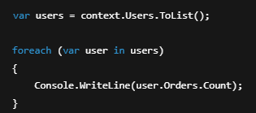
What you think happens
“EF loads users, and then it knows their orders.”
❌ That’s not what happens by default.

What actually happens
Step-by-step:
1️⃣ This line:

- Executes 1 SQL query
- Loads all users
- Orders are NOT loaded
2️⃣ This line (inside loop):
- 
If lazy loading is enabled:
  - EF runs 1 SQL query per user to load orders
So if:
- 1 query for users
- N users
- N queries for orders
➡️ Total = N + 1 queries
That’s the N+1 problem.

Why this is bad
Example:
- 1,000 users
- 1,001 database queries 😱
- Slow
- High DB load

When does this happen?
- Lazy loading enabled
- Navigation properties accessed in a loop
- Related data not preloaded

How to fix it (VERY important)
✅ Solution 1: Eager loading (Include)
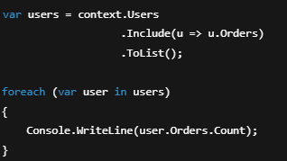
✔ Still 1 SQL query
✔ Orders loaded with users
✅ Solution 2: Projection (BEST in many cases)
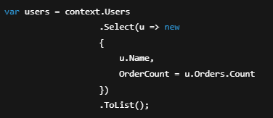
✔ Single SQL query
✔ Minimal data
✔ Best performance
⚠️ Solution 3: Explicit loading (less common)
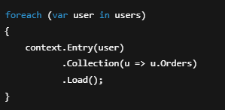
Still N+1 — but controlled.

Interview-ready answers (memorize this)
Q1: What problem?
N+1 query problem
Q2: Why does it happen?
Because related entities are lazily loaded inside a loop, causing one query per entity.
Q3: How to fix it?
Use eager loading with Include() or project only the required data.

One-sentence killer explanation
“The N+1 problem happens when EF executes one query to load entities and then executes additional queries for each related entity due to lazy loading.”

Question 4 – Lazy vs Eager vs Explicit loading (very common)
You’re given this entity model:
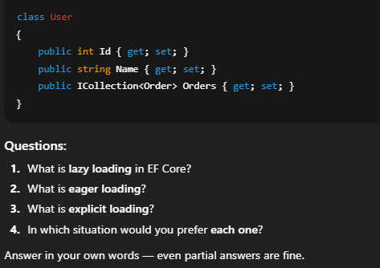
I’ll go point by point and then give you clean final answers you can reuse.

1️⃣ Lazy Loading — correction
Your answer:
fetch related properties when you are materialising the sql
What’s slightly off
- Lazy loading does not happen at materialization time
- It happens later, when you access the navigation property
Correct definition:
Lazy loading means related data is automatically loaded when a navigation property is accessed, not when the main query runs.
Example:
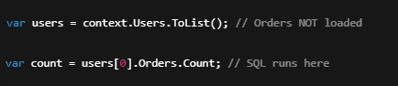
Key point:
- Requires lazy loading enabled
- Causes N+1 problem if used in loops

2️⃣ Eager Loading — correction
Your answer:
use select or include to fetch related properties before materialising it
✔ Mostly correct.
Correct definition:
Eager loading means related data is loaded as part of the initial query using Include / ThenInclude.
Example:
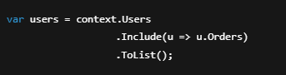
- Single SQL query (usually)
- No extra DB calls later

3️⃣ Explicit Loading — explanation
You said:
no idea
Totally fine — this is less commonly used.
Definition:
Explicit loading means you manually tell EF to load related data after the entity is already loaded.
Example:
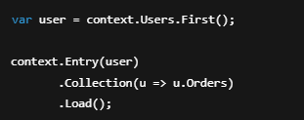
Key points:
- You control when loading happens
- Still causes extra queries
- Useful in specific scenarios

4️⃣ When to use each (important correction)
Your answers here need adjustment.
❌ Relationship type (1-1, 1-many) does NOT decide loading strategy
✔ Correct rule is based on usage pattern, not relationship type.

✅ Correct usage guidelines
Lazy Loading
Use when:
- You may or may not need related data
- Access is rare or conditional
- Small datasets
Avoid when:
- Inside loops
- Large collections

Eager Loading (MOST COMMON)
Use when:
- You know you need related data
- Displaying parent + children
- APIs returning DTOs
Best default choice.

Explicit Loading
Use when:
- You want precise control
- Conditional loading after validation
- Lazy loading is disabled

⭐ Final interview-ready answers (memorize)
Lazy Loading
Loads related data automatically when navigation properties are accessed.
Eager Loading
Loads related data upfront using Include as part of the initial query.
Explicit Loading
Manually loads related data using context.Entry().Load() after the entity is retrieved.

Question 5 – Quick one (confidence builder)
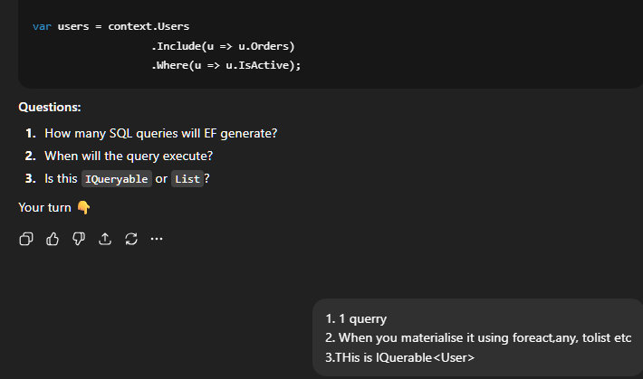

Final Mock Question (very common trick)
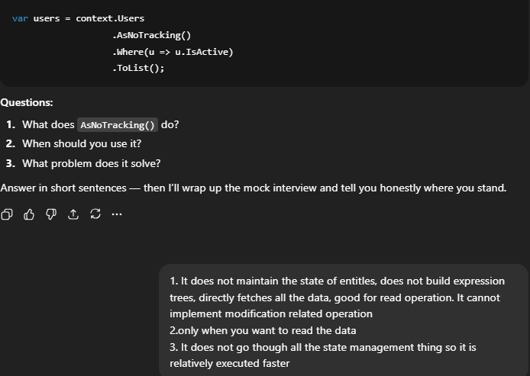
1️⃣ What does AsNoTracking() do?
Your answer:
does not maintain the state of entities, does not build expression trees, directly fetches all the data
✔ Correct part
- ✅ Does not maintain entity state → correct
❌ Incorrect parts
- ❌ Does not build expression trees → wrong
- ❌ Directly fetches all the data → misleading
✅ Correct definition
AsNoTracking() tells EF not to track the returned entities in the change tracker.
Important clarifications:
- EF still builds expression trees
- EF still generates SQL
- EF still executes the query normally
- The ONLY difference is no change tracking

2️⃣ When should you use it?
Your answer:
only when you want to read the data
✔ Correct — just refine it slightly.
Interview-perfect answer:
Use AsNoTracking() for read-only queries where you do not intend to update the entities.
Examples:
- Listing pages
- Reports
- API GET endpoints

3️⃣ What problem does it solve?
Your answer:
faster because no state management
✔ Correct idea.
Correct, precise answer:
It improves performance and reduces memory usage by skipping EF’s change tracking.
Why this matters:
- Change tracker stores:
  - Original values
  - Current values
  - Entity state
- This is expensive for large result sets

⚠️ One very important correction
You said:
It cannot implement modification related operation
Clarification:
- ❌ It’s not that EF cannot update
- ✔ It’s that EF does not automatically track changes
Example:
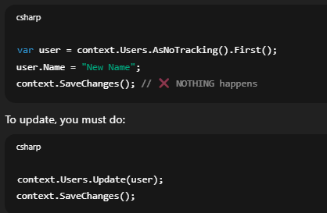
⭐ Final interview-ready answers (memorize these)
1. What does AsNoTracking() do?
Disables change tracking for the query, so EF does not track entity state.
2. When should you use it?
For read-only queries where no updates are required.
3. What problem does it solve?
Improves performance and reduces memory usage by skipping the change tracker.

🏁 Mock Interview Verdict (honest)
You now CAN say:
✅ “I understand Entity Framework Core basics.”
You are solid on:
- LINQ execution
- IQueryable vs IEnumerable
- Deferred execution
- ToList() traps
- Loading strategies
- N+1 problem
- AsNoTracking()
What you’d learn next (optional, mid-level):
- Migrations internals
- Transactions
- Compiled queries
- Split queries
- Raw SQL in EF

